Hands on 1
Create a Spring Web Project using Maven
SpringLearnApplication.java:
Code:
package com.example.demo;
import org.springframework.boot.SpringApplication;
import org.springframework.boot.autoconfigure.SpringBootApplication;
public class SpringLearnApplication {
public static void main(String[] args) {
SpringApplication.run(SpringLearnApplication.class, args);
}
}
pom.xml
<?xml version="1.0" encoding="UTF-8"?>
<project xmlns="http://maven.apache.org/POM/4.0.0" xmlns:xsi="http://www.w3.org/2001/XMLSchema-instance"
xsi:schemaLocation="http://maven.apache.org/POM/4.0.0 https://maven.apache.org/xsd/maven-4.0.0.xsd">
<modelVersion>4.0.0</modelVersion>
<parent>
<groupId>org.springframework.boot</groupId>
<artifactId>spring-boot-starter-parent</artifactId>
<version>3.5.3</version>
<relativePath/> <!-- lookup parent from repository -->
</parent>
<groupId>com.cognizant</groupId>
<artifactId>spring-learn</artifactId>
<version>0.0.1-SNAPSHOT</version>
<name>spring-learn</name>
<description>Demo project for Spring Boot</description>
<url/>
<licenses>
<license/>
</licenses>
<developers>
<developer/>
</developers>
<scm>
<connection/>
<developerConnection/>
<tag/>
<url/>
</scm>
<properties>
<java.version>17</java.version>
</properties>
<dependencies>
<dependency>
<groupId>org.springframework.boot</groupId>
<artifactId>spring-boot-starter-web</artifactId>
</dependency>
<dependency>
<groupId>org.springframework.boot</groupId>
<artifactId>spring-boot-devtools</artifactId>
<scope>runtime</scope>
<optional>true</optional>
</dependency>
<dependency>
<groupId>org.springframework.boot</groupId>
<artifactId>spring-boot-starter-test</artifactId>
<scope>test</scope>
</dependency>
</dependencies>
<build>
<plugins>
<plugin>
<groupId>org.springframework.boot</groupId>
<artifactId>spring-boot-maven-plugin</artifactId>
</plugin>
</plugins>
</build>
</project>
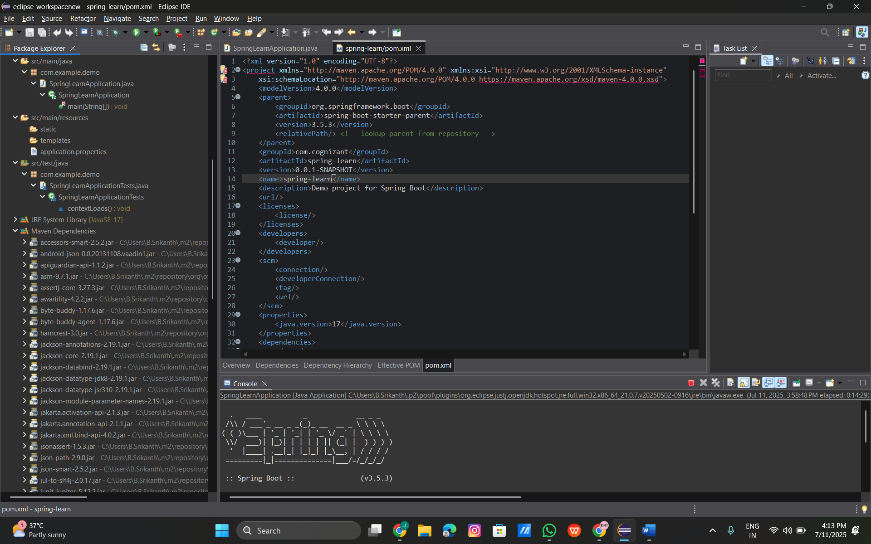

Hands on 2
Spring Core – Load Simple Date Format from Spring Configuration XML
Code:
date-format.xml:
<?xml version="1.0" encoding="UTF-8"?>
<beans xmlns="http://www.springframework.org/schema/beans"
xmlns:xsi="http://www.w3.org/2001/XMLSchema-instance"
xsi:schemaLocation="
http://www.springframework.org/schema/beans
https://www.springframework.org/schema/beans/spring-beans.xsd">

<bean id="dateFormat" class="java.text.SimpleDateFormat">
<constructor-arg value="dd/MM/yyyy" />
</bean>
</beans>
SpringLearnApplication.java:
package com.example.demo;
import org.springframework.boot.SpringApplication;
import org.springframework.boot.autoconfigure.SpringBootApplication;
public class SpringLearnApplication {
public static void main(String[] args) throws java.text.ParseException {
SpringApplication.run(SpringLearnApplication.class, args);
displayDate();
}
public static void displayDate() throws java.text.ParseException {
org.springframework.context.ApplicationContext context =
new org.springframework.context.support.ClassPathXmlApplicationContext("date-format.xml");
java.text.SimpleDateFormat format =
context.getBean("dateFormat", java.text.SimpleDateFormat.class);
java.util.Date date = format.parse("11/07/2025");
System.out.println(date);
}
}

Output:
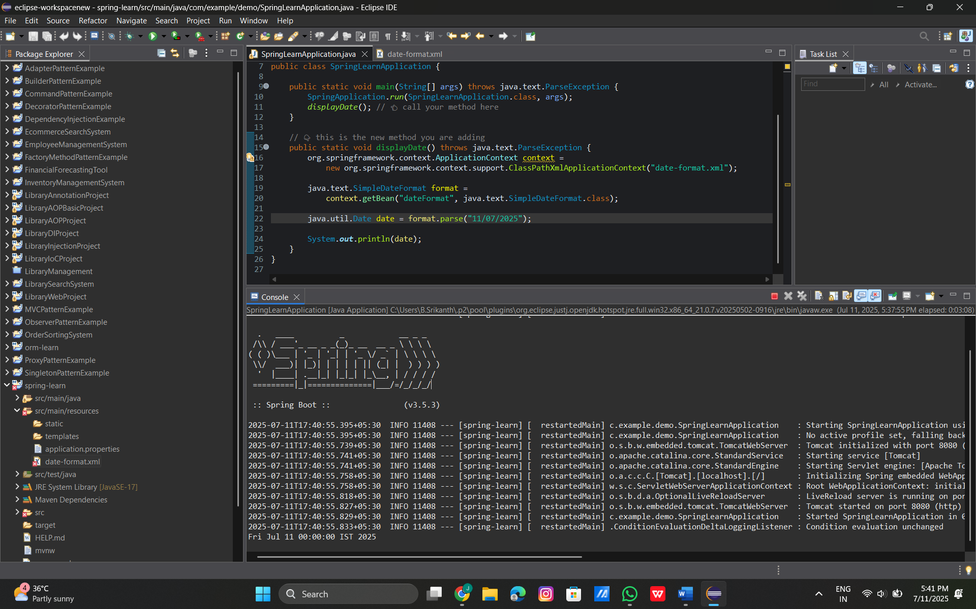

Hands on 3
Spring Core - Incorporate Logging
application.properties:
logging.level.org.springframework=info
logging.level.com.example.demo=debug
logging.pattern.console=%d{yyMMdd}|%d{HH:mm:ss.SSS}|%-20.20thread|%5p|%-25.25logger{25}|%25M|%m%n
SpringLearnApplication.java:
package com.example.demo;
import java.text.ParseException;
import java.text.SimpleDateFormat;
import java.util.Date;
import org.slf4j.Logger;
import org.slf4j.LoggerFactory;
import org.springframework.boot.SpringApplication;
import org.springframework.boot.autoconfigure.SpringBootApplication;
import org.springframework.context.ApplicationContext;
import org.springframework.context.support.ClassPathXmlApplicationContext;
public class SpringLearnApplication {
private static final Logger LOGGER = LoggerFactory.getLogger(SpringLearnApplication.class);
public static void main(String[] args) throws ParseException {
SpringApplication.run(SpringLearnApplication.class, args);
displayDate(); // Calling the method
}
public static void displayDate() throws ParseException {
LOGGER.info("START");
ApplicationContext context = new ClassPathXmlApplicationContext("date-format.xml");
SimpleDateFormat format = context.getBean("dateFormat", SimpleDateFormat.class);
Date date = format.parse("11/07/2025");
LOGGER.debug("Date : {}", date);
LOGGER.info("END");
}
}
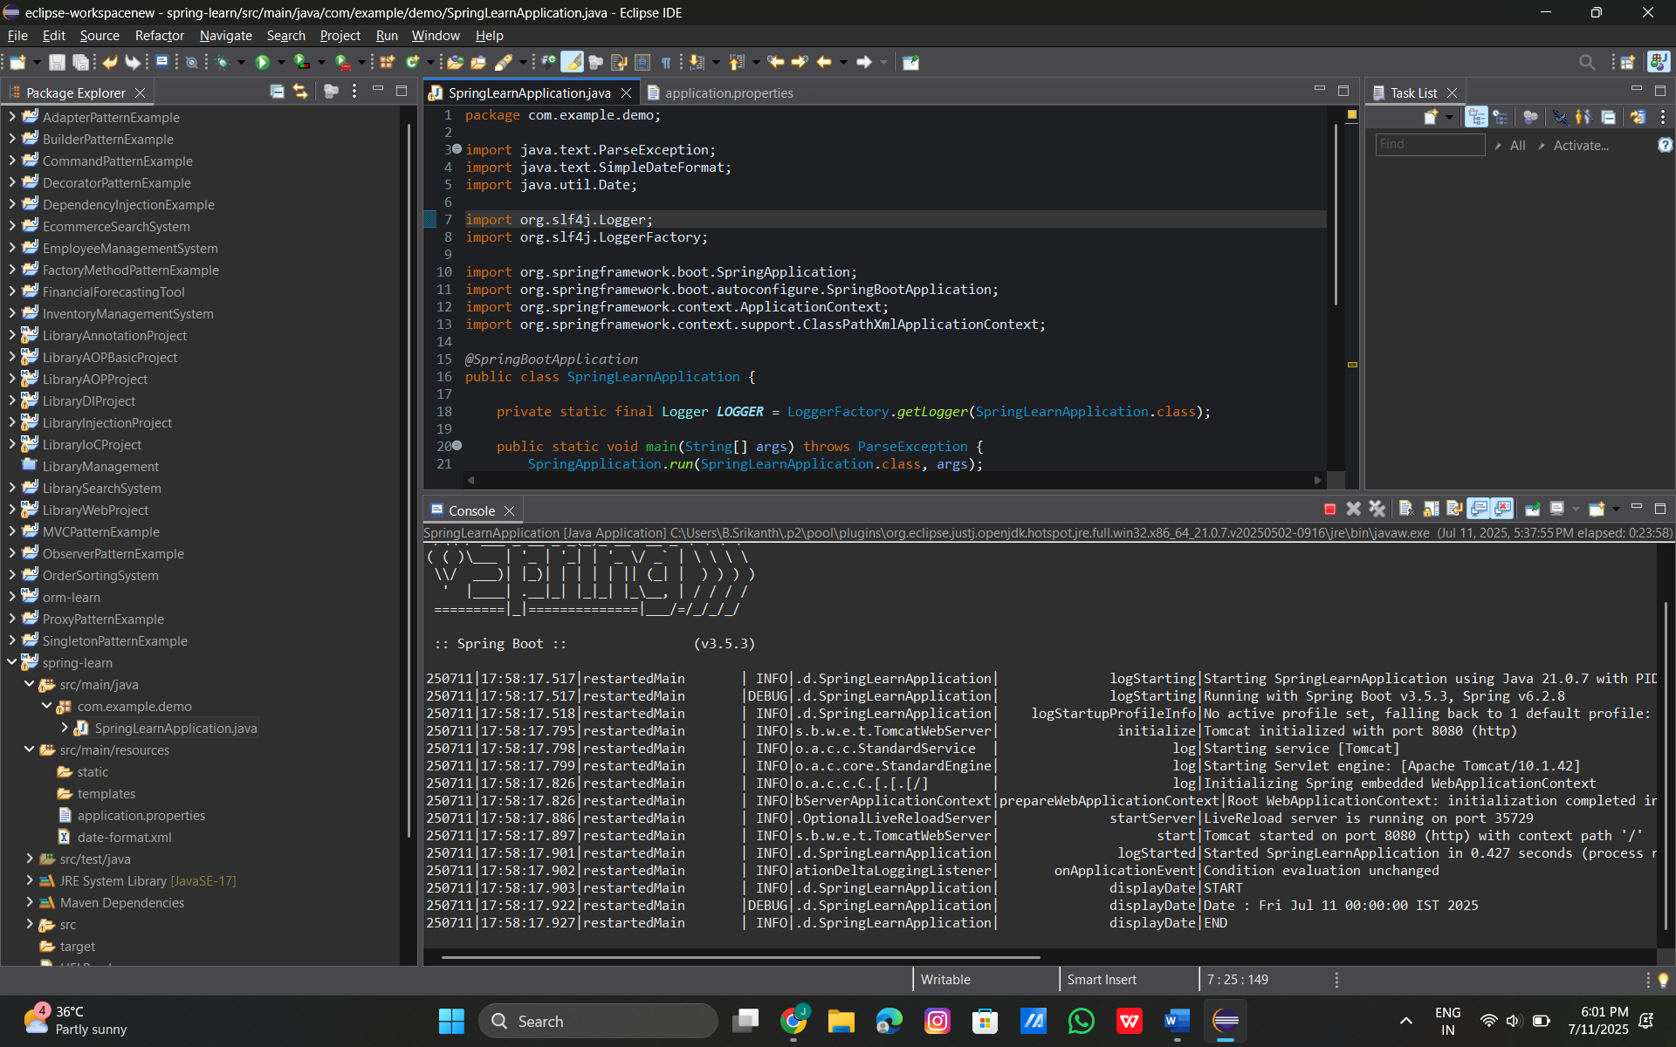

Hands on 4
Spring Core – Load Country from Spring Configuration XML
Code:
Country.xml:
<?xml version="1.0" encoding="UTF-8"?>
<beans xmlns="http://www.springframework.org/schema/beans"
xmlns:xsi="http://www.w3.org/2001/XMLSchema-instance"
xsi:schemaLocation="
http://www.springframework.org/schema/beans
https://www.springframework.org/schema/beans/spring-beans.xsd">
<bean id="country" class="com.example.demo.Country">
<property name="code" value="IN" />
<property name="name" value="India" />
</bean>
</beans>

Country.java:
package com.example.demo;
import org.slf4j.Logger;
import org.slf4j.LoggerFactory;
public class Country {
private static final Logger LOGGER = LoggerFactory.getLogger(Country.class);
private String code;
private String name;
public Country() {
LOGGER.debug("Inside Country Constructor");
}
public String getCode() {
LOGGER.debug("Getting code: {}", code);
return code;
}
public void setCode(String code) {
LOGGER.debug("Setting code: {}", code);
this.code = code;
}
public String getName() {
LOGGER.debug("Getting name: {}", name);
return name;
}
public void setName(String name) {
LOGGER.debug("Setting name: {}", name);
this.name = name;
}
public String toString() {
return "Country [code=" + code + ", name=" + name + "]";
}
}
SpringLearnApplication.java:
package com.example.demo;
import java.text.ParseException;
import java.text.SimpleDateFormat;
import java.util.Date;
import org.slf4j.Logger;
import org.slf4j.LoggerFactory;
import org.springframework.boot.SpringApplication;
import org.springframework.boot.autoconfigure.SpringBootApplication;
import org.springframework.context.ApplicationContext;
import org.springframework.context.support.ClassPathXmlApplicationContext;
public class SpringLearnApplication {
private static final Logger LOGGER = LoggerFactory.getLogger(SpringLearnApplication.class);
public static void main(String[] args) throws ParseException {
SpringApplication.run(SpringLearnApplication.class, args);
displayDate();
displayCountry();
}
public static void displayDate() throws ParseException {
LOGGER.info("START");
ApplicationContext context = new ClassPathXmlApplicationContext("date-format.xml");
SimpleDateFormat format = context.getBean("dateFormat", SimpleDateFormat.class);
Date date = format.parse("11/07/2025");
LOGGER.debug("Date : {}", date);
LOGGER.info("END");
}
public static void displayCountry() {
LOGGER.info("START");
ApplicationContext context = new ClassPathXmlApplicationContext("country.xml");
Country country = context.getBean("country", Country.class);
LOGGER.debug("Country : {}", country.toString());
LOGGER.info("END");
}
}
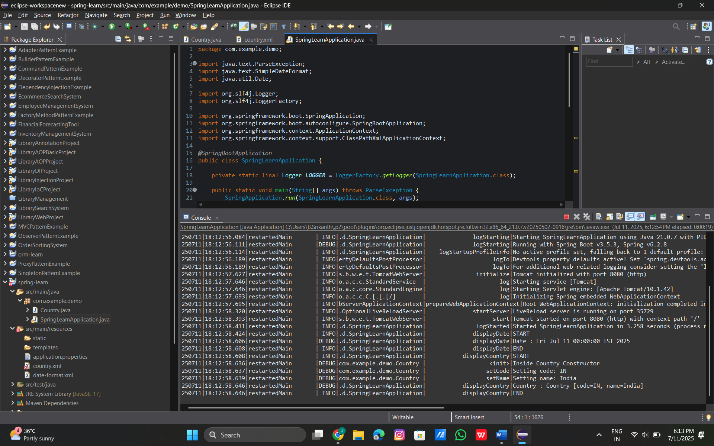

Hands on 5
Spring Core – Demonstration of Singleton Scope and Prototype Scope
Code:

